# CS 255 System Design Document Template

## UML Diagrams

### UML Use Case Diagram

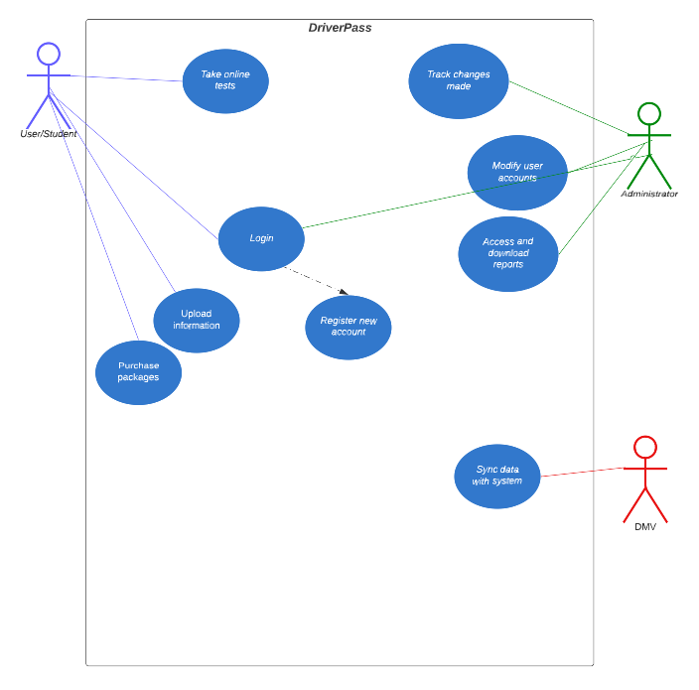

### UML Activity Diagrams

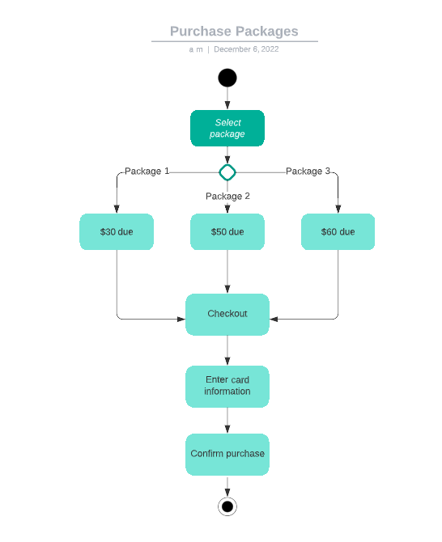

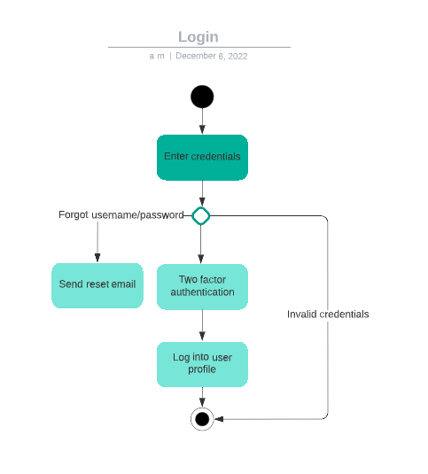

### UML Sequence Diagram

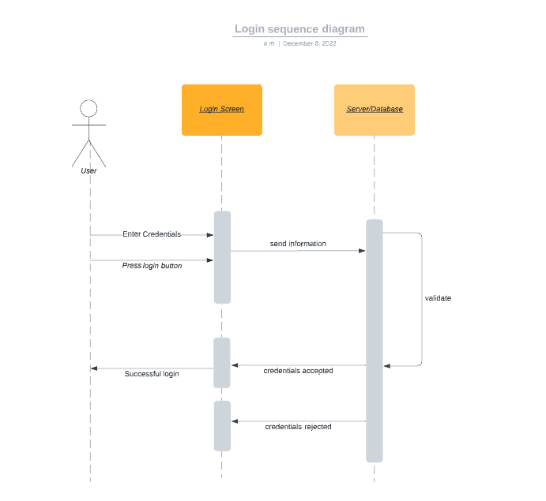

### UML Class Diagram

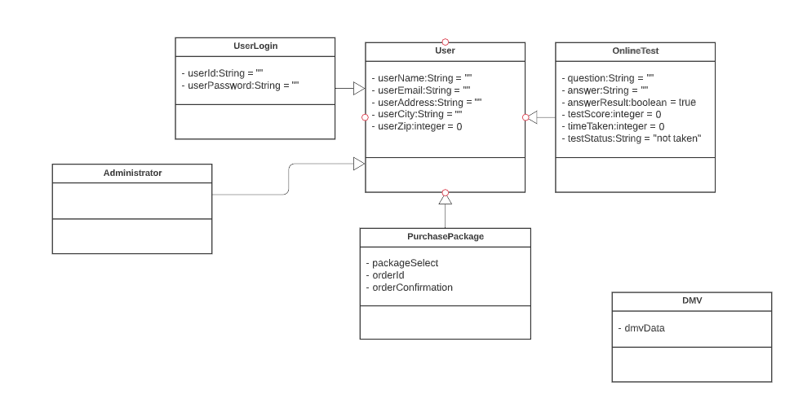

## Technical Requirements

The technical requirements of my system include using an object-oriented language, hardware that can handle storing a lot of data due to the DMV, and software that can be used to create a system for all different types of platforms and devices. The system will be cloud-based.